Family History wasn’t as prevalent in Harry Potter’s book 4: The Goblet of Fire. But don’t you worry, I figured it out!

My decorations were minimal tonight:

As the week wears on, I’m getting a bit less and less artistic. Haha. Next time, and yes there will be a next time, I will do one a week. But that means re-decorating each week. There are pros and cons to this. LOL. I added the Goblet of Fire to our dinner table with our names coming out of the tissue paper flames. It looked great and was super easy, yet added to the atmosphere we were creating.

Harry Potter dinner menu for book 4, The Goblet of Fire:

I went simple tonight with a Marie Calendar’s Beef pie. Harry ate beef casseroles, goulash, beef pastries, and stew, so our beef pie was a hit. As for dessert, we choose eclairs, and I purchased them at a local pastry shop. Had I had time, I would have made my mom’s “cream puffs”! Hers are the best! (see my mom’s homemade recipe for “cream puffs” a family favorite). But I did make the genuine warm butterbeer created in 1855 in Great Britain with no alcohol. I really liked it. One of my daughters thought it was too sweet. But the way to make “Warm Butterbeer” required me to learn how to make butterscotch from scratch in the process! I love learning new things.

The best one is where you make your own butterscotch from scratch. Yep it makes a difference and it’s worth it. It reminds me of making a vanilla steamer. For 2 cups milk add 1/2-3/4 cup of the butterscotch syrup (recipe below). Slowly heat up, and whisk till frothy and at the temperature you'd like. (Some say add cream soda to the steamy mixture, I didn't). Then top it off with fresh whipped heavy whipping cream.

Warm Butterbeer from 1855 alcohol free
https://ashleemarie.com/hot-butterbeer-recipe-video/
Butterscotch from scratch

Family History activity:

Hogwarts hosted schools from other countries in this Harry Potter book! So, the Family History activity was all about finding out where your family heritage comes from.

My husband showed us on FamilySearch where to find the fan chart that displayed what countries your ancestors came from and which is most prevalent in your family DNA.

It was also fun for me to see which generation came to America. For some of our relatives it was as close as my great grandparents who arrived from Slovenia in 1890s, to as far back as the pilgrims who crossed the ocean on the Mayflower.

Another activity, if you have lots of energy, or you have kids old enough who’d set it all up for you, is to have a family Tri-Wizarding tournament! My mother made an entire maze using cardboard with a trophy at the end of the maze! We had to race in, grab the trophy, and out of the maze while being timed! My kids loved it.

The pictures are not very good, but you get the idea, and my kids were so little back then that the cardboard was tall enough that it truly was a maze for them, but the parents could watch all the fun from up high. My kids still remember the fun they had. There are so many types of games and relays and races that your family could play, I’m sure you’ll have no trouble coming up with you own Tri-Wizard Family Tournament!

Playing games and making memories is all part of creating your own Family History! It doesn’t have to be as elaborate as the Maze made out of cardboard, but even a few family competitive games at the dinner table, can make lasting memories. Growing up "Nertz" was part of getting together with the cousins and great aunts! Those are still great memories 30+ years later.

Have fun making memories and learning about where you came from!! Bon Appetite!

Reposted from Instagram and FaceBook March 2020#foreverfamilytrees #familyhistory #harrypotter #makingmemories #makeamemory #warmbutterbeer #familyhistorywith harrypotter #gobletoffire #familygames

4 and the Goblet of Fire 2000
menu:
beef casserole pg 67
goulash pg 215
stew pg 98
rock cakes pg 53
*marie calendar beef pies?
*eclairs pg 180 – buy at pastry store
jam tarts pg 193
*Warm Butter beer

decorations:
house banners on back of chairs
*tissue paper to look like goblet of fire – with torn pieces of paper with names on it
gold balloons or balls with wings for snitch

activity: do a family Olympics. International relations: find out about where your family heritage comes from

harry potter wizarding world original butter beer:

- 1 cup light or dark brown sugar
- 2 tablespoons water
- 6 tablespoon butter
- 1/2 teaspoon salt
- 1/2 teaspoon cider vinegar
- 3/4 cup heavy cream, divided
- 1/2 teaspoon rum extract
- Four 12-ounce bottles cream soda

PREPARATION

STEP 1
n a small saucepan over medium, combine the brown sugar and water. Bring to a gentle boil and cook, stirring often, until the mixture reads 240 F on a candy thermometer.
Stir in the butter, salt, vinegar and 1/4 heavy cream. Set aside to cool to room temperature.
Once the mixture has cooled, stir in the rum extract.
In a medium bowl, combine 2 tablespoons of the brown sugar mixture and the remaining 1/2 cup of heavy cream. Use an electric mixer to beat until just thickened, but not completely whipped, about 2 to 3 minutes.

Butterbeer Recipe
- 1 cup cream soda
- 1 cup soda water
- 2 tablespoons butterscotch syrup
- 2 tablespoons whipped cream
- 2 tablespoons caramel syrup
- Pinch of salt
Combine the cream soda, soda water, and butterscotch syrup in a bowl, then mix the last three ingredients together in a separate bowl. Add the soda mixture to a cup (or a mug for a Wizarding World feel) and top with the whipped cream mixture. For an easy cream hack, switch out the topping ingredients for a premade foam topping — try the Salted Caramel Whipped Foam Topping from Skinny Mixes or opt for the Sweet Foam Coffee Topper from Reddi Whip. For an adult spin on this themed beverage, add a splash of rum.
To serve, divide the brown sugar mixture between 4 tall glasses (about 1/4 cup for each glass). Add 1/4 cup of cream soda to each glass, then stir to combine. Fill each glass nearly to the top with additional cream soda, then spoon the whipped topping over each.

​

1855-1600 warm butter beer

INGREDIENTS

- 3 Pints 1.6 Liters Good English Ale (Your Choice)
- 5 Egg Yolks
- 200 grams Demerara Sugar
- 100 grams Butter
- 1 tsp Nutmeg
- 1 Pinch Ginger
- 1 Pinch Clove

Garnish
- Fresh Grated Nutmeg

INSTRUCTIONS

- Add Ale or Beer to a Pot
- Add Spices
- Heat until Warm
- In a bowl, combine Egg Yolks and Sugar until smooth
- Add Sugar and Egg mix to the Ale (Beer). Be careful not to add it too quickly and don’t heat the Ale up too much so the eggs scramble.
- Bring back to a simmer. The Butterbeer should resemble Tea with Milk in color.
- Add Butter and bring back to simmer
- Serve with Grated Nutmeg. Can be served Cold.
KEYWORDbeer, british ale, butter beer, butterbeer, egg yolk, ginger ale, harry potter, hogsworth, nutmet

NGREDIENTS
- 2 cups milk
- 1/4 cup butter
- 1/4 cup brown sugar
- 2–3 tablespoons hot butterscotch topping
- 1 cup cream soda

INSTRUCTIONS
- Combine milk, butter, and brown sugar and whisk together. Heat in the microwave for 3 minutes.
- Stir and heat for an additional 3-4 minutes until milk is foaming.
- Remove from microwave and whisk together until the butter is well mixed in and sugar is completely dissolved.
- Heat hot butterscotch topping for 30 seconds. Then, stir in 2 tablespoons of hot butterscotch into the milk mixture until completely dissolved.
- Next, add in 1 cup of cream soda and mix well. (You can cheat and add root beer if you don’t have cream soda, but it’s much better with cream soda.)
- Top with Hot Butterscotch Whipped Cream.

HOW TO MAKE BUTTERBEER
- Make your own Butterscotch sauce – I know it may sound silly but it makes such a difference vs the store bought stuff.
- Add some apple cider vinegar to the sauce to cut the sweetness. When just making butterscotch sauce for an ice cream topping I don’t bother with this but because we’re adding this sauce to soda and other sweet drinks it cutting the sweetness makes a huge difference
- Use rum extract to get that rum flavoring but keeping it kid friendly and non alcoholic. If you want a boozy version obviously use real rum – but add it to the drink itself, not the syrup.
- don’t boil or overheat this drink – with all the dairy in this drink adding too much heat will actually cause curdling and no one wants that – so heat low and slow and stop when it’s the temperature you are looking for.
- 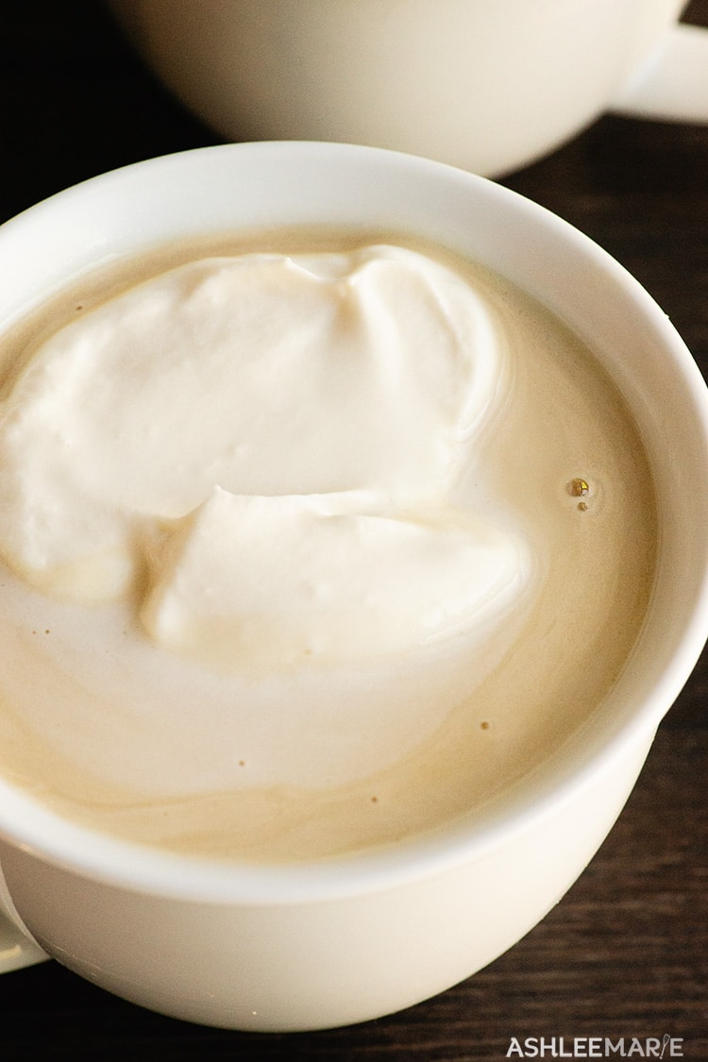

WHAT IS BUTTERBEER?
- Butterbeer is a fictional drink from the Harry Potter series, that is now a reality thanks to the Wizarding World of Harry Potter. The book mentions cold butterbeer in bottles or hot butterbeer in “foaming tankards”.
- JK Rowling describes butterbeer as tasting “a little bit like less-sickly butterscotch” and it does have alcohol in it in the book (enough to get house-elves drunk).
- The Executive Chef for Universal Parks went through about 15-16 versions before they got one that JK Rowling herself approved of! The park version is non alcoholic and dairy free to be allergy friendly.
- Now you can get this approved drink at 3 locations – Universal Studios Orlando Florida, Universal Studios Hollywood California and the Warner Brothers Studio Tour in England
- OR you can make one of my versions at home and enjoy (obviously not dairy free though)

HOT BUTTERBEER RECIPE
- If you love these butterbeer treats as much as I do, I’d love a 5 star review. Be sure to share on social media and tag me if you make it @ashleemariecakes! If you want to stay updated on new recipes sign up for my newsletter and join my Facebook Group!

ngredients

Butterscotch
- 1 1/2 C brown sugar
- 1/2 C light corn syrup
- 1/3 C butter
- 2/3 C heavy whipping cream
- 1 tsp salt
- 1 tsp apple cider vinegar
- 1/2 tsp rum extract

Foam
- 3.5 oz marshmallow creme/fluff
- 1 C heavy whipping cream

Hot Butterbeer
- 3/4 C brown sugar
- 1 1/2 C milk
- 2 C heavy whipping cream
- 1 1/2 C cream soda
US Customary – Metric

Instructions

Butterscotch
- In a medium saucepan bring the brown sugar, corn syrup and butter to a boil
- boil until the syrup reaches 240 degrees (remembering to adjust for altitude)
- take off the heat and let cool slightly, about 5 mins
- stir in the heavy whipping cream
- add the salt, apple cider vinegar and rum extract and stir
- let cool

Whipping topping
- beat the marshmallow creme, heavy whipping cream and 2 Tbsp of the butterscotch syrup together – you want it to be fluffy and white but not stiff

Hot Butterbeer
- In a medium saucepan heat the milk and brown sugar up until the brown sugar is just dissolved
- Add the heavy whipping cream and bring up to the temperature you want to serve your hot butterbeer at (don't let it boil and stir frequently)
- Add 1/2-3/4 C of the butterscotch syrup. Stir until incorporated and take off the heat
- Add the cream soda and serve the hot butterbeer with some of the whipped topping
- refrigerate leftover butterscotch and topping

cold butter beer

The base of this is a homemade butterscotch syrup. Do know the difference between caramel syrup and butterscotch? Caramel syrup is made with white sugar and butterscotch using brown sugar – pretty small difference but that’s it. My Caramel syrup actually uses half white and half brown sugar – cause I like the deeper flavor. So this butterscotch syrup is based on that recipe but with all brown sugar – I like to use half dark brown sugar, but that’s options. Now straight butterscotch syrup isn’t quite right for butterbeer SO I also add some apple cider vinegar to counter balance the sweetness and a little rum extract.
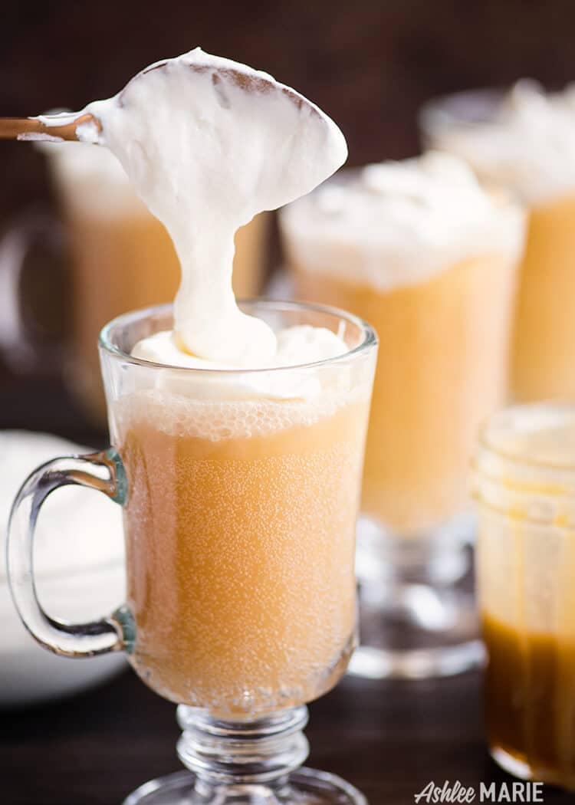
I recently did a live video where I make and compared all the butterbeer recipes I found online along with my version – and the kids and I did a taste test! Not too surprising I liked mine best. I felt the extract version was too fake, the huffington post version was just cream soda and whipped cream with a slight butterscotch flavor, and second place was my version with store bought butterscotch syrup. And of course homemade butterscotch is always better than store bought, so WINNER! But I’d love to hear what you think!!!

Quick tip – since stirring soda will get rid of a lot of the carbonation the trick I found was I warmed up the butterscotch syrup a little (if it had cooled all the way) and stir the 2 Tbsp into just a few oz to liquefy it then add the rest of the soda.

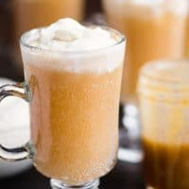

Cold Butterbeer Recipe
This cold butterbeer recipe is easy to make and tastes just like the sweet treat from the harry potter parks
4.46 from 96 votes
Print Pin Rate
Prep Time: 15 minutes
Cook Time: 20 minutes
Total Time: 35 minutes

Servings: 17 8 oz cups

Calories: 232kcal

Author: Ashlee Marie

Ingredients

Butterscotch
- 1 1/2 C packed light or dark brown sugar I use both
- 1/2 C light corn syrup
- 1/3 C butter
- 1 teaspoon salt
- 2/3 cup heavy whipping cream
- 1 teaspoon apple cider vinegar
- 1/2 teaspoon rum extract

Whipped Topping
- 3.5 oz marshmallow creme/fluff
- 1 C heavy whipping cream

Soda
- 2 2 liters cream soda cold
US Customary - Metric

Instructions

Butterscotch syrup
- In a medium saucepan bring the brown sugar, corn syrup and butter to a boil
- boil until the syrup reaches 240 degrees (remembering to adjust temperature for altitude)
- take off the heat and let cool slightly - about 5 mins.
- Then stir in the heavy whipping cream
- add the salt, apple cider vinegar and rum extract and stir
- let cool

Topping
- beat the marshmallow creme, heavy whipping cream and 2 Tbsp of the butterscotch syrup together - you want it to be fluffy and white but not stiff

Butterbeer
- stir 2 Tbsp into every 12 oz of cold cream soda - or 3/4 C into a full 2 liters
- pour the butterbeer into a glass and add some of the topping
- refrigerate the leftover butterscotch and topping

frozen butter beer
Kay three ways to slush it up – 1. Run the mixture through an ice cream maker for like 25 mins. By far the quickest and easiest IMO, it’s the one I use all the time. 2. pour the butterbeer mixture into a large container and place it in your freezer, and every 20 mins give it a stir. It will take a few hours to get slushy. 3. prefreeze some of the creme soda in a an ice cube tray, like a day ahead. Then when your ready to make it use half ice cubes, half cold soda and the syrup and blend with a hand blender or normal blender.
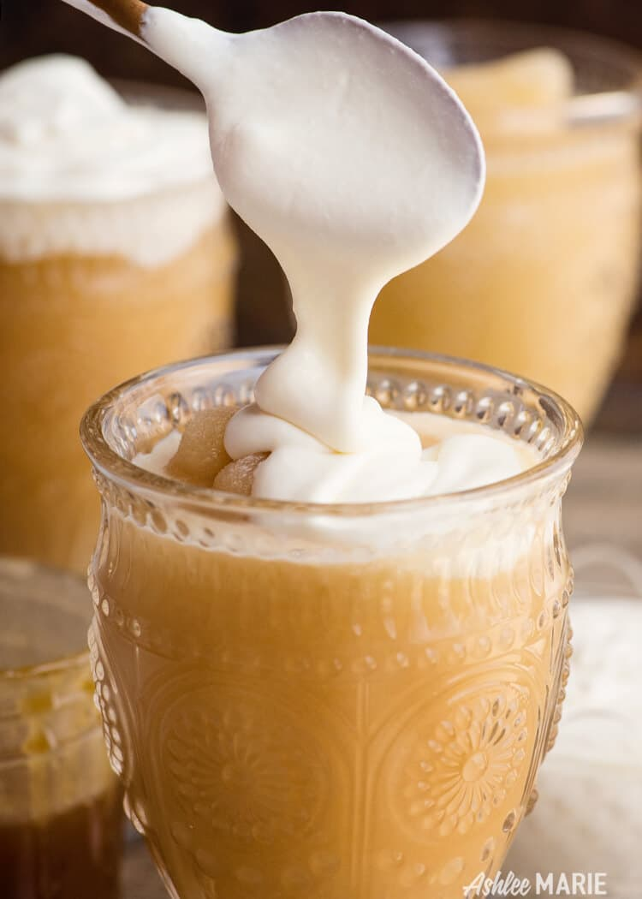
And of course the glorious soft marshmallowy topping – just like the cold butterbeer, it’s SOOOO good. I actually used the same batch of tweaked butterscotch and the same batch of topping for like 4 batches! Just left them in the fridge and pulled it out for every batch, so it’s actually really easy, I just get some cream soda and pull out the ice cream maker and all the work is done!

Soda doesn’t stay slushy long it will get a little melty on the edges so I keep stirring as I’m ejoying it to keep the texture even throughout, but then the topping gets mixed in a little so it’s up to you! Personally I tend to keep some topping on hand and add more as I eat it off the top…. It’s seriously so good! Enjoy this live video I made making this recpie AND all the other online versions and doing a taste test!
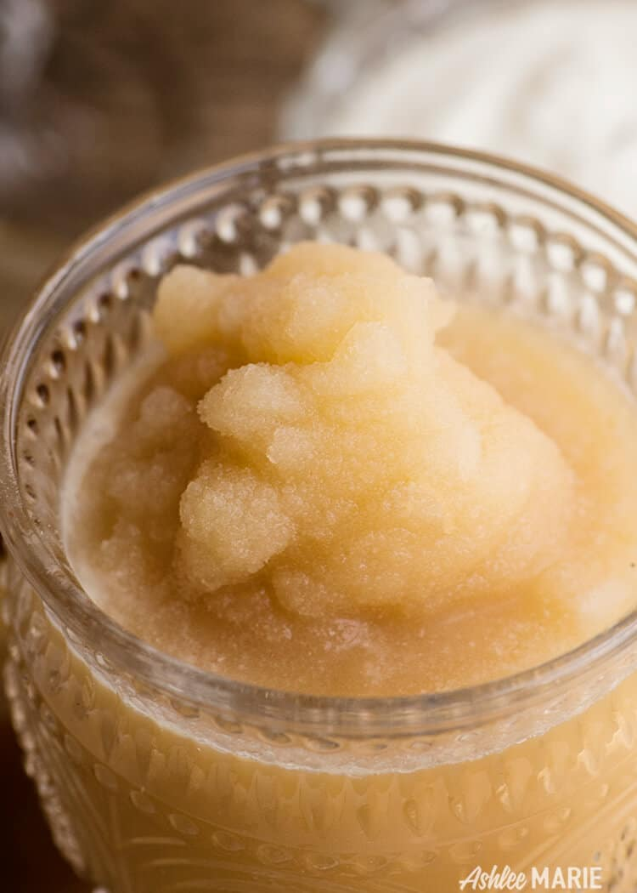
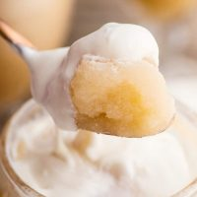

Frozen Butterbeer recipe and video
This homemade frozen butterbeer tastes amazingly like the sweet treat at Universal Studios
0 from 0 votes
Print Pin Rate
Prep Time: 15 minutes
Cook Time: 20 minutes
Total Time: 35 minutes

Servings: 17 8 oz cups

Calories: 352kcal

Author: Ashlee Marie

Ingredients
- 1 1/2 C light or dark brown sugar I use both
- 1/2 C light corn syrup
- 1/3 C butter
- 1 teaspoon salt
- 2/3 C heavy whipping cream
- 1 teaspoon apple cider vinegar
- 1/2 teaspoon rum extract
- 4 liters cream soda cold
- 3.5 oz marshmallow creme/fluff
- 1 C heavy whipping cream
US Customary - Metric

Instructions

Butterscotch syrup
- bring the brown sugar, corn syrup and butter to a boil
- boil until the syrup reaches 240 degrees (remembering to adjust temperature for altitude)
- take off the heat and let cool 5 mins, then stir in the whipping cream, apple cider vinegar and rum extract
- let cool completely

Frozen Butterbeer
- stir 2 Tbsp into every 12 oz of cold cream soda - or 3/4 C into a full 2 liters
- Freezing 3 options
- a - run through an ice cream maker for 25 mins
- b - pour into a large container and place in the freezer, stir ever 20 mins for 2 hours or more until slushy
- c - freeze 2/3rd of the cream soda in an ice cube tray overnight - mix the ice cubes, with some cold cream soda (1/3) and the syrup and blend with a hand blender

Topping
- beat the marshmallow creme, heavy whipping cream along with 2 Tbsp of the butterscotch syrup together
- pour the butterbeer into a glass and add some of the topping
- refrigerate the leftover butterscotch and topping

BUTTERBEER RECIPE
Serve this well chilled and in a frosty mug or warm on those chilly Wisconsin nights
- 1 cup heavy whipping cream
- 4 tbsp powdered sugar
- 2 tbsp vanilla butter nut flavoring, divided
- 2 tbsp MERINGUE [whipped egg whites}
- 2tbsp Butterscotch syrup or schnapps
- 2 cans or bottles of your favorite cream soda, I like Sprechers...
Combine heavy whipping cream, powdered sugar, 1 tsp of vanilla butter nut flavoring, whip 2 egg whites until it forms peaks. Add the remaining 1 tsp of the vanilla butter nut flavoring to 12 oz. of the cream soda and gently stir to combine. Spoon cream mixture on top and drizzle with butterscotch... enjoy!

